5. Develop a system using UML for implementing Online Course Reservation System. This system is organized by the central management system. The student first browses and selects the desired course of their choice. The university then checks the availability of the seat if it is available the student is enrolled for the course.

1.COLLABORATION DIAGRAM:-

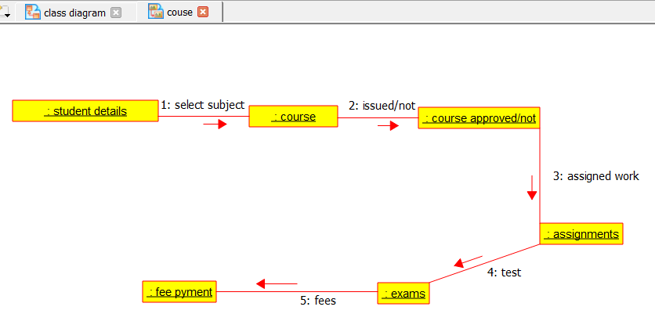

2.USECASE DIAGRAM:-

